PAAO CURSO DE LIDERAZGO LEADERSHIP PROGRAM: 2018-2019

GENERAL GUIDELINES DEADLINE: JULY 31, 2018

Mission:
The purpose of the Pan-American Association of Ophthalmology (PAAO) Leadership Development Program (Curso de Liderazgo) is to provide both orientation and skill development to future leaders of national ophthalmology societies and subspecialty societies affiliated with the PAAO.

Program Goals:
- Identify individuals with the potential to become leaders in Ophthalmology.
- Provide orientation and skills to allow potential leaders to promote Ophthalmology locally, nationally and across the hemisphere.
- Accelerate the promotion of program graduates into leadership positions locally, nationally and across the hemisphere.
- The PAAO Curso is a joint investment and commitment between the PAAO, the Candidate and the National Society or Subspecialty Society.
Guidelines for Participation:
- Only National Ophthalmology Societies and Subspecialty Societies affiliated with the Pan-American Association of Ophthalmology may submit a program participant nomination to the PAAO Curso Selection Committee.
- Candidates should seek the position thru activities within the national society / subspecialty society and the ophthalmology community. Candidates may not self-nominate.
- The National Ophthalmology Society or Subspecialty Society interested in the program may nominate only one candidate to participate in the program.
- The nominee must be a current active member/miembro titular of his/her national ophthalmology society or affiliated subspecialty society for at least three (3) years and must be a member in good standing of the PAAO at the time of nomination.
- The nominee must agree to participate in all elements of the PAAO Curso, including but not limited to:
- attend all designated meetings (see page 3; orientation at AAO meeting; January work session in San Francisco; final session at AAO meeting)
- complete a project that will benefit their nominating society or their community
- work with a local mentor assigned by the Curso committee
- The nominee must have fluency in English. With participants come from English-, Spanish- and Portuguese-speaking countries, English becomes the ‘lingua franca’.
- Nominees that do not complete the program (attend all three meetings, work with a mentor, and complete a project) will not receive a certificate or any proof of partial attendance.
- Cost for participation will be shared by the nominating national ophthalmology society or affiliated subspecialty society, the individual participant, and the PAAO (see ‘Cost Sharing’ chart on page 4).
- Estimated annual PAAO Curso de Liderazgo class size: 16 - 18 participants.
Participant Selection:
- The PAAO Curso de Liderazgo Selection Committee will review and select participants based on completed nomination forms received by July 31, 2018 (Incomplete forms/documents or those receive after the July 31 deadline will not be reviewed).
- Selected participants and the nominating National Ophthalmology Society or affiliated subspecialty society will be notified by the Curso de Liderazgo Selection Committee immediately following the Committee’s participant selection decisions.
- Nominees who are not selected for the 2018-2019 Curso de Liderazgo may be re-nominated the following year (but new nomination forms should be sent).
PROGRAM OUTLINE

The 2018-2019 PAAO Curso de Liderazgo participants must attend the following sessions:

October 27 – 30, 2018
Annual Meeting of the American Academy of Ophthalmology
Chicago, Illinois – USA (Hotel and Rooms to be announced)
a) Friday, October 26, 2018
- PAAO/PAOF Presidents’ Reception (6:30 pm – 8:00 pm) (optional)
b) Saturday, October 27, 2018
- 2018-2019 Curso de Liderazgo Orientation Session (7:00 am – 9:00 am)
  - 1st hour: Participants will attend a joint orientation session with participants in the American Academy of Ophthalmology Leadership Development Program.
  - 2nd hour: Incoming and Outgoing Curso groups will meet to discuss projects and experiences
c) Monday, October 29, 2018
- PAAO Board of Directors meeting (6:00 am – 8:00 am) (optional)

January 17-19, 2019
Work Session
San Francisco, California – USA, (Hotel Argonaut; arrive Thursday night, Depart Sunday afternoon)
- Curso participants will meet jointly with participants of the AAO Leadership Development Program (AAO LDP) and the European Leadership Development Program (EuLDP).
- Participants will participate in interactive workshops on topics relevant to leadership which may include leadership principles, communication, political advocacy, media relations, effective committee meetings and other pertinent topics.
- Participants will have an opportunity to network informally with classmates and PAAO leaders during social events.

October 12 – 15, 2019
Annual Meeting of the American Academy of Ophthalmology
San Francisco, California – USA (Hotel and Rooms to be announced)
- Friday, October 11, 2019
  - PAAO/PAOF Presidents’ Reception (6:30 pm – 8:00 pm) (optional)
- Saturday, October 12, 2019
  - 2018-2019 Curso de Liderazgo Final Session (7:00 am – 9:00 am)
**Select projects will be presented to the outgoing and incoming Curso groups**
- Monday, October 14, 2019
- PAAO Board of Directors meeting (6:00 am – 8:00 am) (optional)
Class of 2018-2019 Curso participants are invited to attend the PAAO Board of Directors breakfast meeting.

COST SHARING SUGGESTION
PAN-AMERICAN ASSOCIATION OF OPHTHALMOLOGY | NATIONAL OPHTHALMOLOGY SOCIETY/ AFFILIATED SUBSPECIALTY SOCIETY | PARTICIPANT
1. Agenda materials, resource books and meeting preparation | 1. Airfare and lodging for the 2018 Annual Meeting of the American Academy of Ophthalmology in Chicago, Illinois USA* | 1. Registration fee for the 2018 Annual Meeting of the American Academy of Ophthalmology in Chicago, Illinois USA *
2. Speakers, Consultants, and Moderators | 2. Airfare and lodging for the 2019 Work Session to be held jointly with the Academy’s Leadership Development Program session in San Francisco, California USA *
3. Social Events | 3. Airfare and lodging for the 2019 Annual Meeting of the American Academy of Ophthalmology in San Francisco, California USA* | 2. Registration fee for the 2019 Annual Meeting of the American Academy of Ophthalmology in Francisco, California USA*
4. Airfare and lodging for moderators and instructors
* Note: Some National Ophthalmology Societies or Affiliated Subspecialty Societies may choose to arrange for different financial commitments for these segments between the individual participant and the society. The Pan-American Association has no responsibility whatsoever in these matters.

National Ophthalmology Societies

- Argentine Council of Ophthalmology
- Bolivian Society of Oftalmología
- Brazilian Council of Ophthalmology
- Canadian Ophthalmological Society
- Chilean Society of Ophthalmology
- Colombian Society of Ophthalmology
- Ophthalmology Society of Costa Rica
- Cuban Society of Ophthalmology
- Dominican Society of Ophthalmology
- Ecuadorian Society of Ophthalmology
- Salvadorian Association of Ophthalmology
- Guatemalan Association of Ophthalmology
- Haitian Society of Ophthalmology
- Honduran Society of Ophthalmology
- Ophthalmological Society of the West Indies
- Mexican Society of Ophthalmology
- Nicaraguan Society of Ophthalmology
- Panamanian Society of Ophthalmology
- Paraguayan Society of Ophthalmology
- Peruvian Society of Ophthalmology
- Portuguese Society de Oftalmologia
- Puerto Rican Society of Ophthalmology
- Spanish Society of Ophthalmology
- Uruguayan Society of Ophthalmology
- Venezuelan Society of Ophthalmology

Affiliated Subspecialty Societies

- ALACCSA-R (Latin American Association of Cataract Surgery and Anterior Segment and Refractive)
- CLADE (Latin American Council on Strabismus)
- CLAN (Latin American Neuro-ophthalmology Club)
- CLEO (Latin American Council on Ultrasound in Ophthalmology)
- Pan-American Cornea Society (PanCornea)
- Pan-American Glaucoma Society (PAGS)
- Pan-American Low Vision Society
- Pan-American Ocular Inflammatory Disease Society (SPEIO)
- Pan-American Ocular Pathology Society ‘Lorenz E. Zimmerman’
- Pan-American Oculoplastic Society (SOPANOP)
- Pan-American Ophthalmic Oncology Society (PAOOS)
- Pan-American Society of Retina and Vitreous (SPRV)
- Pan-American Society of Retinopathy of Prematurity (SP-ROP)
- Pan-American Trauma Association (APTO)
- SOPLA (Latin American Pediatric Ophthalmology Society)

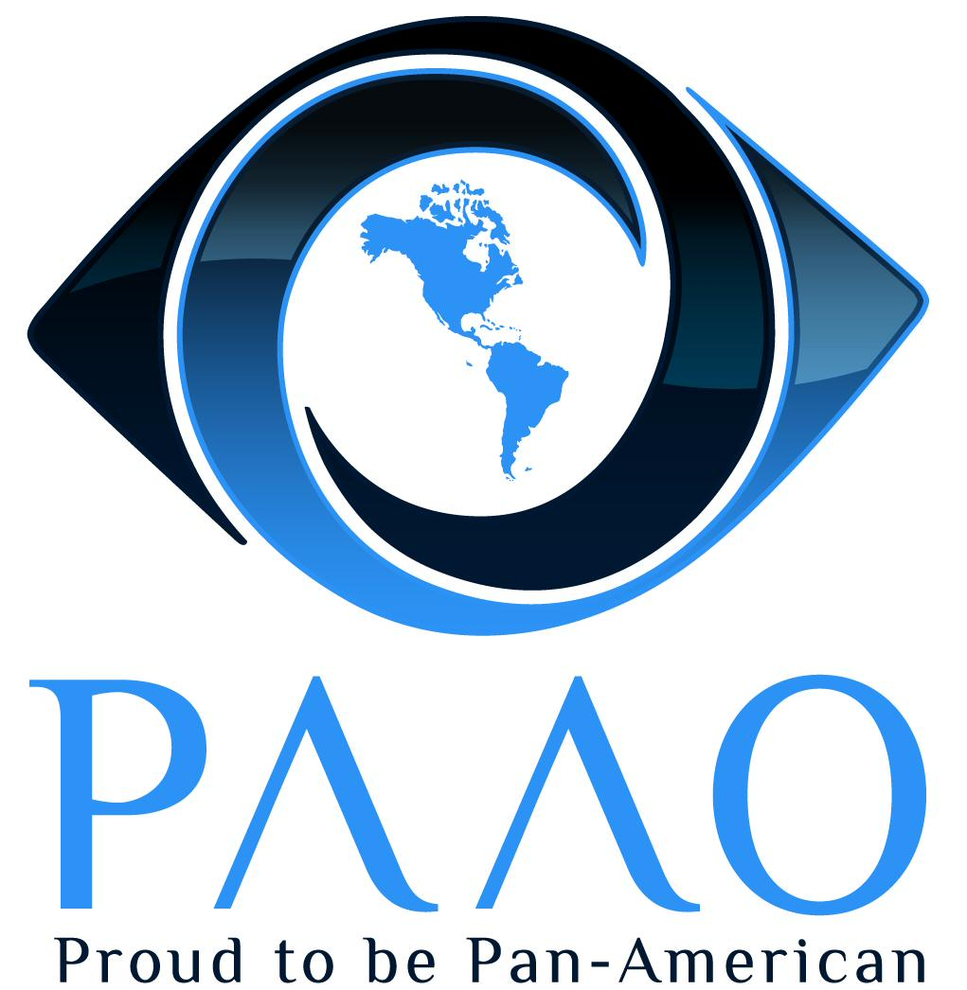LEADERSHIP PROGRAM

NOMINATION FORM

Instructions:

This nomination will be reviewed by the Selection Committee of the Curso de Liderazgo of the Pan-American Association of Ophthalmology (PAAO). Please print legibly or type the information requested. Use additional sheet(s) of paper if necessary to supplement your answers. Please do not write ‘See attached C.V.’ The Selection Committee will carefully review all applications and requires that this nomination form be completed in its entirety.

SOCIETY: Please complete Section A
NOMINEE: Please complete Section B
DEADLINE: JULY 31, 2018

Section A (to be completed by National Ophthalmology Society or Affiliated Subspecialty Society)

Nominee Information
Name of Nominee:
Mailing Address:
City: State:
Zip Code: Country:
Phone: Fax:
Email: Date of Birth: / /
Practice type:
Are you a member/member-in-training of the PAAO? / PAAO ID #

Description of Participation
I) Number of years as a member of the nominating society
II) Please list the society activities in which the nominee has participated (i.e., leadership positions, committee or task force involvement, etc.)

III) Please list any leadership positions in organized medicine held by the nominee

IV) Please list the nominee’s membership in other medical associations

V) To the best of your knowledge, are the nominee’s practice principles consistent with the principles of the National Society/Subspecialty Society and the Pan-American Association of Ophthalmology?

VI) Please list the name(s) and title(s) of the individual(s) submitting this nomination form on behalf your National Ophthalmology Society/Affiliated Subspecialty Society. Please include all information requested.
Name:
Title:
Nominating Society:
Society Address:
Zip Code: Country:
Phone: Fax:
Email:

Section B (to be completed by nominee)

I) Please describe your interest in the Curso de Liderazgo, including why you should be selected by the Curso de Liderazgo Selection Committee (please attach additional sheets if necessary)

II) Please describe how your participation in the Curso de Liderazgo might benefit your national society/subspecialty society (please attach additional sheets if necessary)

III) In addition to participating in a leadership role in your national society/subspecialty society, are you interested in participating on Pan-American Association of Ophthalmology committees, task forces or projects?
Please describe your areas of interest and/or expertise:

IV) If selected, I agree to participate in all designated elements of the Curso de Liderazgo (i.e., attend all meetings. See program description under Program Outline in General Brochure)
Yes No
V) On the following page, please give a title and short description of your proposed Curso project. Your project should be of benefit to your nominating society. It should be focused and able to be completed within the timeframe of the Curso de Liderazgo. Abstracts of previous Curso projects are available on the PAAO website, at https://paao.org/index.php?component=com_articles&id_art=12#alumni.

Signature of Nominee Date

Please include a clear digital photo of the nominee (head and shoulders: 3x4 cm, at least 150 dpi) with this nomination and any supplementary materials you would like the Leadership Program Selection Committee to review concerning this nomination.

Please return the completed nomination form by July 31, 2018 to:
Curso de Liderazgo Selection Committee
c/o Zelia Correa MD PhD
Pan-American Association of Ophthalmology
1301 South Bowen Road #450
Arlington, Texas 76013 - USA
Fax: 817-275-3961 Tel: 817-275-7553 email: info@paao.org
Proposed Curso Project

Your project should be of benefit to your nominating society. It should be focused and able to be completed within the timeframe of the Curso de Liderazgo. Curso graduates and abstracts of previous Curso projects are available on the PAAO website, at https://paao.org/index.php?component=com_articles&id_art=12#alumni.
Proposed Project Title:
Mentor:
(If you already have one; we recommend a Curso de Liderazgo graduate. See the link above or contact the PAAO Administrative Office)
Purpose of the Project (include benefit to your nominating society; 100-200 words)

Methods (How will you execute your project including costs, funding and sustainability; 100-200 words)

Projected (expected) outcomes (100-200 words)

